Machine Learning Testing
Performance testing plan for machine learning models used with incident data
Project: ServiceNow Incident Lifecycle Automation | Phase: Development - Performance Testing

1. Purpose and Scope
This plan verifies that machine learning models used in the solution (for example incident classification, priority prediction or recurring-incident detection) are accurate, fast to score, and stable as data volume and patterns change.
In scope:
- Model accuracy measures on held-out data
- Scoring latency and throughput (single and batch)
- Robustness to missing, noisy or unusual data
- Drift monitoring and retraining triggers
Out of scope:
- Feature engineering research
- Infrastructure outside the model-serving path

2. Test Objectives
- Confirm the model meets the agreed accuracy thresholds on unseen data.
- Confirm scoring time supports real-time use on the incident form and batch use for reports.
- Confirm the model behaves sensibly with incomplete or unusual inputs.
- Define how drift is detected and when the model is retrained.

3. Test Scenarios and Targets
Targets below are proposed starting points. Confirm or replace them with agreed service levels before execution.
ID | Scenario | Metric | Proposed target
ML-01 | Evaluate on held-out test set | Accuracy, precision, recall, F1 | Meets agreed thresholds per class
ML-02 | Check performance on rare categories | Per-class recall | No class falls below the agreed minimum
ML-03 | Single-record scoring latency | Response time | 1 second or less
ML-04 | Batch scoring of a large incident set | Throughput | Completes within the agreed batch window
ML-05 | Inputs with missing or malformed fields | Robustness | Handled with default or clear rejection; no crash
ML-06 | Recent data compared with training data | Drift indicators | Alert raised when drift exceeds the agreed limit
ML-07 | Concurrent scoring requests | Latency, error rate | 95th percentile within 2 seconds; errors under 1%

4. Test Approach
- Split data into training, validation and test sets before any tuning; never tune on the test set.
- Report metrics overall and per class, not only overall accuracy.
- Compare against a simple baseline (for example always predicting the most common class) to show the model adds value.
- Schedule periodic re-evaluation on recent incidents to detect drift.

5. Tools
Tool / area | Use
Python | scikit-learn, pandas for metrics and evaluation
Load generator | JMeter, k6 or equivalent for scoring endpoints
Monitoring | Dashboards for accuracy over time and input distribution

6. Test Data and Environment
- Non-production scoring endpoint mirroring production configuration.
- Anonymised historical incident data with reliable labels.
- Version control for model, data snapshot and evaluation scripts.

7. Entry and Exit Criteria
Type | Criteria
Entry | Model trained and registered; test data held out and labelled; thresholds agreed.
Exit | Accuracy and latency targets met; drift and retraining process documented; results signed off.

8. Risks
Risk | Mitigation
Labels in history are inconsistent | Review a sample of labels and correct before evaluation
Class imbalance hides weak spots | Report per-class metrics and use appropriate sampling
Data changes after release | Monitor drift and retrain on schedule

9. Results Log
ID | Scenario | Result | Pass / Fail | Notes

Process Diagram
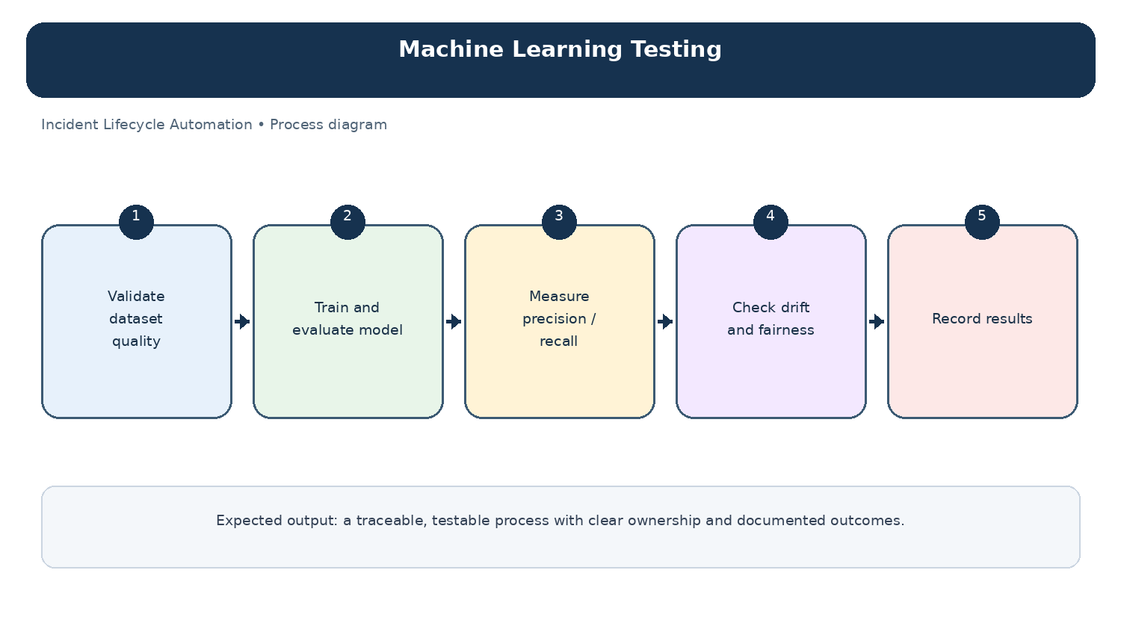
Diagram: Machine Learning Testing — project-specific process overview.

